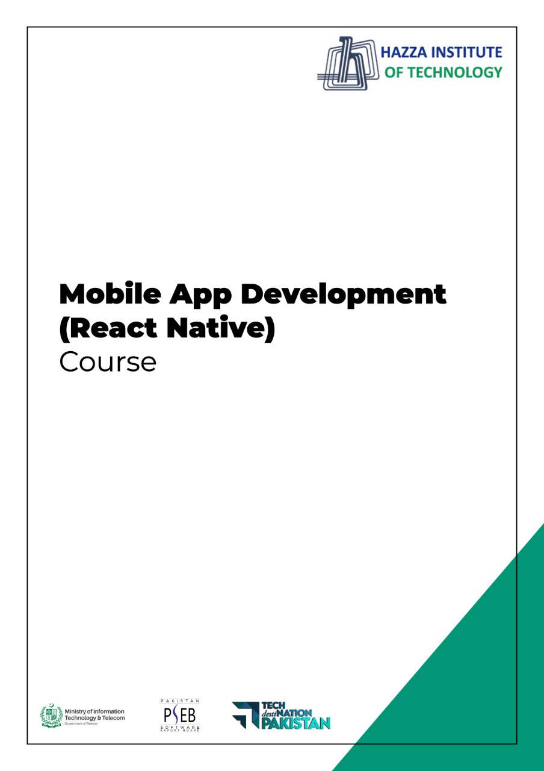

**(Flutter)**

Lab 8 (Session 1)

**Total Time:**

**3 hours**

**Pre-Lab Activities:**

* + Familiar with Flutter Database

**Learning Outcomes:**

* + Student will learn how data is saved and retrieved from database.

**Student Activities:**

* + create firebase project
  + configure it in Android project

**Lab Tasks 1:**

* + Create a main page and define routes for register.dart, welcome.dart, chat.dart, login.dart
  + Create Welcome screen as below as your first screen

**Lab Tasks 2:**

* + Graphical user interface, application

    Description automatically generatedCreate a Register page shown below, on click of registration button it must register user in firebase database.

**Lab Tasks 3:**

* + Create sign in page as shon in figure below , on click of login button it must authenticate user if user exist in database it redirect toward chat,dart screen

